Group Summary

Path : Reports >> Group Summary.
Steps to reach Category Summary:
Step 1 : Reports in Steps to reach Group Summary : Open the Reports module from the Billing Application(POS).
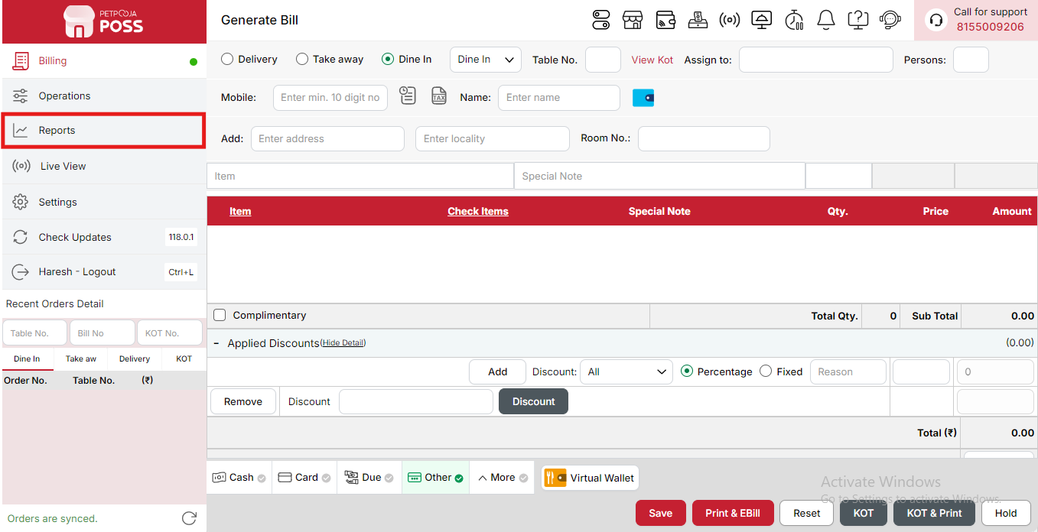
{Image Name: Reports Option,
Description: The red box highlights the “Reports” option in the sidebar menu. This section allows users to view and analyze various business reports, such as sales, billing, and order summaries, helping in effective tracking and decision-making.Here is an image of Step 1 Report in Steps to Reach Group Summary}
Step 2 : Group Summary in Steps to reach Group Summary : Select Group Summary to view sales and performance summaries for each item group, including total sales value and quantity sold within the selected duration.
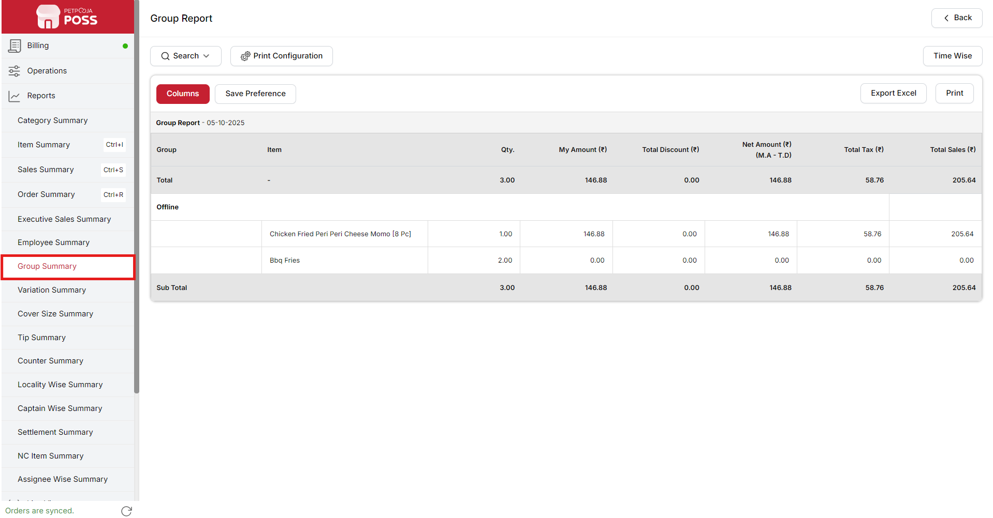
{Image Name: Group Summary,
Description: The red box highlights the Group Summary option under the Reports section. This feature allows users to view detailed summaries of grouped sales data, helping in tracking performance by item category or group for better business insights.Here is an image of Step 2 Group Summary in Steps to Reach Group Summary}

Key features of Group Summary :
(Group Summary) Note: If you are not able to see or use the Group Summary option in your billing application, it means that you do not have the required permission. To enable this, you need to go to the Owner Dashboard and open the User Management section. Inside User Management, you will find a permission called Group Summary Show Button — you must checkmark this option to give access.If you are not able to view old day reports, then you also need to enable the Days Restriction permission. Inside the same User Management section, select No Restriction so that you can view reports for any date.After allowing these permissions, perform a manual sync so the system updates the rights properly. Once the sync is done, log out from the billing application and then log in again. After this process, the Group Summary option will become visible, and you will be able to view all reports without any problem.
- (Group Summary) Group Report - [Date]: Displays a summarized overview of sales data for a selected date, categorized by groups (such as Online, Dine-in, etc.). It helps analyze total quantities sold, revenue, discounts, taxes, and overall sales performance.
- (Group Summary) Group: Represents the category or source of sales, such as Online,Offline, Bar, Food etc.It helps to understand where the sales are coming from.
- (Group Summary) Item: Lists the specific products sold within each group (e.g., Cheese Nachos, Chicken Burger [online], Grilled Tikki Chicken Burger). This helps identify which items contribute to total sales.
- (Group Summary) Qty.: Shows the total quantity sold for each item. It indicates how many units of a particular item were sold within the selected period.
- (Group Summary) My Amount (₹): Displays the total value of sales before any discounts are applied. It represents the gross sales amount for each item.
- (Group Summary) Total Discount (₹): Indicates the total discount given on each item or group. It helps track how much value was reduced from the original sales price due to discounts or offers.
- (Group Summary) Net Amount (₹) (M.A - T.D): Represents the net sales amount after subtracting total discounts from the original (My Amount). This shows the actual revenue before tax.
- (Group Summary) Total Tax (₹): Displays the total tax applied to each item or group. It helps monitor how much tax was collected on sales.
- (Group Summary) Total Sales (₹): Shows the final sales amount after adding applicable taxes to the net amount. It reflects the total revenue generated from sales.
- (Group Summary) Sub Total: Summarizes the combined totals of quantity, amount, discount, tax, and sales for a specific group (e.g., Online). It helps quickly view group-wise performance.
- (Group Summary) Total: Represents the grand total of all groups combined. It gives the complete sales summary for the selected date, including all quantities, discounts, net amounts, taxes, and total sales.
- (Group Summary) Sub Total: Displays the combined totals for all items in the report, including total quantity, total amount, discounts, net amount, tax, and total sales. It provides a summarized view of overall group performance before applying additional charges or deductions.
- (Group Summary) Waived Off: Represents the amount that has been deducted or not charged from the total bill. It helps track discounts or adjustments manually waived off from the final sales.
- (Group Summary) Delivery Charge: Displays the additional charge applied for delivering orders. It helps in identifying extra income earned through delivery services.
- (Group Summary) Container Charge: Represents the charge applied for packaging or containers used for delivering food or products. It helps in accounting for additional operational costs.
Search Button (Group Summary) : The Search button is used to find the report for a specific date or time. It helps you quickly see sales details for the selected period. After choosing the date or time, you can click on Search to view the report.
- From (Group Summary) : The From option is used to select the starting date for the group report. It means the report will begin from this date.
- To (Group Summary) : The To option is used to select the ending date for the group report. It means the report will show data up to this date.
- Group (Group Summary) : The Group option is used to enter your group name properly. After entering the correct group name, you can view the detailed report for that specific group within the selected date range.
- Time Wise Option (Group Summary) : The Time Wise Option is used when you want to see the report for a specific time period within a day. After turning it ON, you can choose both date and time — for example, from 10:00 AM to 5:00 PM — to see sales during that time. If you keep this option OFF (Without Time Wise Option), then the report will show the whole day’s data for the selected date range without filtering by time.
Configure Column (Group Summary): Used to show or hide different columns in the report by checking or unchecking the boxes. If you want to see that option in the report, you have to check it, and if you want to hide it, you have to uncheck it.
- (Configure Column) Item: Shows the name of the item included in the group summary. You can check this to display it in the report or uncheck it to hide it.
- (Configure Column) Qty.: Shows the total quantity of each item sold within the group. You can check this to view it in the report or uncheck it to hide it.
- (Configure Column) My Amount (₹): Shows the total selling amount for the item before any discounts. You can check this to display it in the report or uncheck it to hide it.
- (Configure Column) Total Discount (₹): Shows the total discount applied on the item within the group. You can check this to show discount details or uncheck it to hide them.
- (Configure Column) Net Amount (₹) (M.A - T.D): Shows the net amount after subtracting the total discount (Total Discount) from the My Amount. You can check this to view it in the report or uncheck it to hide it.
- (Configure Column) Total Tax (₹): Shows the total tax amount added to the sales for each item. You can check this to see tax details or uncheck it to hide them.
- (Configure Column) Total Sales (₹): Shows the final total amount after adding taxes and applying discounts. You can check this to display it in the report or uncheck it to hide it.
(Group Summary) Print Button: The Print Button is used to print the report. If you want to take a printout of the report, you just need to click on the Print button.
If you get an error saying “Please assign one printer for report print”, then follow these steps:
- Go to Operation → Bill/KOT Print → Multiple Printer Settings.
- Select and edit one printer that you want to use for printing the report.
- In that printer setting, there is an option called “Use this printer for report print”.
- Check this box and save the setting.
After doing this, you will be able to print the report successfully using the selected printer.
(Group Summary) Print Configuration: This section is used to set how your report will look when you print it. You can change the format, size, and what details to show on the printed page.
- (Print Configuration) Show Bill Header: If you check this option, the header (top part with company or shop name) will appear on the print.
- (Print Configuration) Show Bill Footer: If you check this option, the footer (bottom part with notes or messages) will appear on the printed report.
- (Print Configuration) NONE: Select this option if you don’t want to apply any specific print format or layout. The report will print in the default basic format without additional formatting or sections.
- (Print Configuration) Display To Date on Print: If you check this option, the “To Date” of the report will be shown on the printed page.
- (Print Configuration) Display Time on Print: If you check this option, the time will be displayed on the print along with the date.
- (Print Configuration) Display Summary Box on Print: If you check this option, a summary box will appear at the end of the report showing total amounts and other summary details.
- (Print Configuration) Display Print Date & Time on Print: If you check this option, the date and time when the report was printed will appear on the print.
- (Print Configuration) Main Width: Used to set the width of the report on the printed page. For example, 500 means the report will be printed with that width size.
- (Print Configuration) Font Size: Used to set the text size of the printed report. You can increase or decrease it as needed.
- (Print Configuration) Cancel: Click this button to close the print configuration window without saving any changes.
- (Print Configuration) Save:Click this button to save all the changes you made in the print configuration settings.
(Group Summary) Export Excel: If you want to download or save the report in Excel format, you have to click on the Export Excel button. This will create an Excel file of the report that you can open and use in Microsoft Excel.

